Name: _____________
Lab Partners Names:_________________
Lab date:_______________
Class Period:_______________

Comparative Embryology

Arizona Science Standards:
- S4-C4-PO3, 5, 6

Ag Standards:
- 17.4 –Portray the scientific principles and processes involved with biological evolution

Objectives:
- Correctly identify vertebrate embryological stages
- Describe how comparative embryology shows change over time.

Background:
Even before Darwin proposed the theory of evolution through natural selection, Karl Ernst von Baer claimed that the most closely related any two species are, the more similar their development. His idea set the stage for linking the study of ontogeny (the development of the individual through a single life cycle) to phylogeny (the relatedness of species through descent from a common ancestor). When Darwin brought together the diverse lines of evidence to demonstrate that new species arose from pervious species, he included the findings from studies on embryos.
Von Baer, who discovered the mammalian egg as part of his detailed studies on animal development, observed that vertebrate animals, during the early stages of their embryological development, seem to have a common design, whereas the adult forms show differences. Arm buds from different species, for example, are virtually indistinguishable when they first form on the embryo, yet they may develop into a wing, an arm or a flipper.
In the early stages of growth when vital organs originate, the developmental sequences, or ontogeny, of all vertebrates are similar. As the fertilized egg transforms into an adult, the general vertebrate plan is modified during growth as each species acquires its adult species pattern.
It is your turn to be a scientist! Your group has 8 different organisms in the baggie in front of you and your group. It is your duty to correctly place the stages in order, and to identify what the organism is.

Pre-lab questions
  - What is ontogeny?

  - What is phylogeny? Describe two activities we have done to look at this concept

  - Who discovered that vertebrate animals have a common design during development?

Materials:

- Baggie with stages of embryo development

Procedure:

    - Take the pieces out of baggies
    - Place into groups based on stage
    - Figure out which stages go with which organism
    - Check final answer with teacher copy
    - Answer post activity questions

Post Activity Questions:

- How does comparative embryology show change over time?

- Which stage was the hardest to differentiate between? Why do you think this is so?

- Which organism was the easiest to place in the correct order? Why do you think so?

- Why do you think that species look similar at the earliest stages of embryonic development?

- Could understanding comparative anatomy help agriculture in the fight against pests?

THE NEXT TWO PAGES ARE TO BE CUT OUT BEFORE THE ACTIVITY DEPENDING ON WHICH SET YOU WOULD LIKE TO USE IN YOUR CLASSROOM
FOR THIS PAGE YOU SHOULD END UP WITH 32 PIECES PER BAG, PER GROUP!
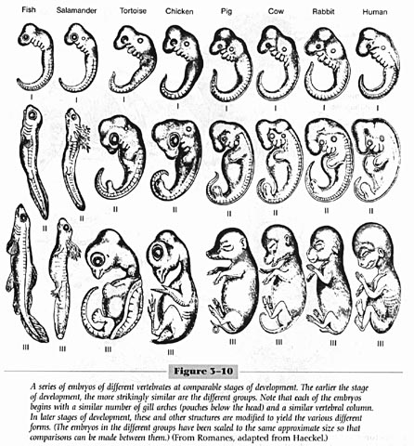

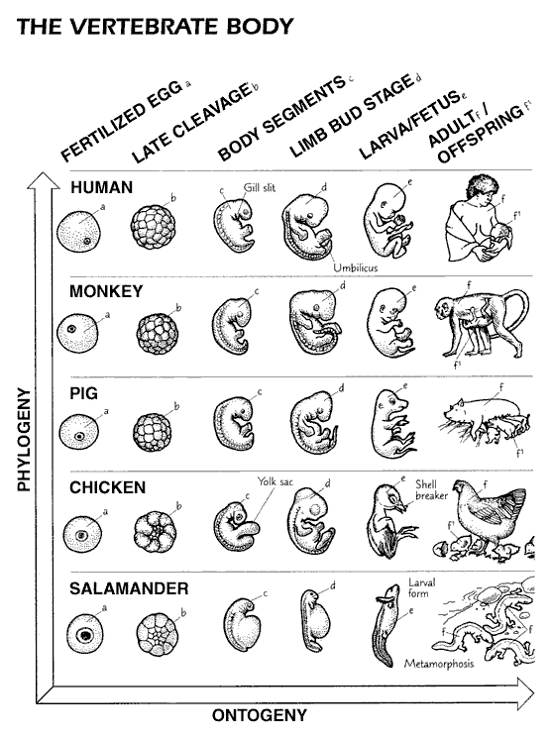

http://www-tc.pbs.org/wgbh/evolution/library/04/2/pdf/l_042_03.pdf

FOR THIS PAGE YOU SHOULD END UP WITH 36 PIECES OF PAPER

